Link Sheet 24/03, Palm Sunday

Readings: Mark’s Passion Gospel

Collect: True and humble king,
hailed by the crowd as Messiah:
grant us the faith to know you and love you,
that we may be found beside you
on the way of the cross,
which is the path of glory.

This week we pray for:
Sunday | King Charles and all in positions of power and authority
Monday | Our community
Tuesday | Peace in the world
Wednesday | Ourselves and our loved ones
Thursday | All who suffer
Friday | All who have died
Saturday | All who mourn

Parish News:
We are awaiting a date for our Confirmation service. If you would like to be confirmed please speak to Rev’d Lois.

April Diary:
6th Saturday 12pm Wedding of Danny Garret and Emily Days Harrison
7th Sunday 10.30am Baptism of Roman Barker and Regan Roberts
17th Wednesday 7pm PCC in the Parish Room

Holy Week at St Anne’s
24th Palm Sunday Service 10.30am
25th Monday 7pm Compline led by Victoria Millsop
26th Tuesday 7pm Compline led by Gina Bailey
27th Wednesday 7pm Compline led by Joyce Lownsbrough
28th Maundy Thursday Service 6.30pm
29th Good Friday Service 2pm followed by hot cross buns
30th Saturday 9am Decorating Church for Easter
31st Easter Day 10.30am with Prosecco

Readings for next week: Isaiah 25.6-9, Acts 10.34-43, Mark 16.1-8

Our Weekly Services:
Thursdays 10am Holy Communion
Sundays 10.30am Parish Eucharist
Tea and Coffee are served after our services, please do join us

Notes:
- The Mass Setting is St Thomas, music is available from the back of church.
- If you would like to receive communion in your seat, please let one of the sides people know.
- Ingol Food Bank Donations can be left at the back of Church
- We now welcome donations by card, we have a card machine at the back of church for use after the service.

Quick Links

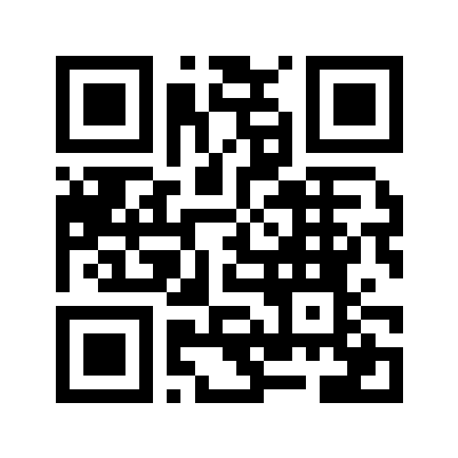
Church Website Church Facebook Donate to Church

